✴

Smart Farmer

**Smart Farmer Application Journey Map**

**SCENARIO**

**Browsing, booking, attending, and rating a local city tour**

# Entice

How does someone initially become aware of this process?

# Enter

What do people experience as they begin the process?

# Engage

In the core moments in the process, what happens?

# Exit

What do people typically experience

as the process finishes?

# Extend

What happens after the experience is over?

## Steps

What does the person (or group) typically experience?

**Visit the website or app**

The user should navigate to our website or app

The app first check the Weather of particular location

**Check the Weather**

**View the Humidity of The soil**

Using the app user can check the soil

**Check the Soil Moisture**

Moisture whether it is dry or not

The user should login to the app by

using mail or phone number

**Login to the App**

The app use

hygrometer to measure the

Humidity

**Check the humidity**

App can intimate the Result

**Switch on the Motor**

**Alert Message**

**Switch on/off the motor**

**Ensure the yield of the crop**

**Submitting Feedback**

**Farming in the user profile**

**Personalized Work**

If the field is Dry We can able to Switch on the Motor

Using app user can switch on/off the motor From anywhere

User can get alert when certain soil humidity level

reached

The User can writes are view and gives

ideas of the app

After the growth of the crop we can

Ensure the yield of the crop

Farmer should not engage themselves

fulltime in the field, they can feel relax by using

this application

In the customer profile they can see the data about the field.

Created in partnership with

## Interactions

What interactions do they have at each step along the way?

It show the Temperature and humidity of our field

Signup/Sign in page for the users

Weather Forecast shows the weather for routine days

Completed experiences section of the profile on the website, iOS app, or Android app

“Leave a feedback” modal window within the profile on the

website, iOS app, or Android app

Customer's email ( website like Gmail)

**People:** Who do they see or talk to?

**Places:** Where are they?

**Things:** What digital touchpoints or physical objects would they use?

## Goals & motivations

Help me understand our Land Field and climate condition

Access from anywhere at any time

Help me feel confident about where to go and spent time in other work

Remotely we can access the motor switch

Help me get the field temperature

Help me to see what could be doing next

At each step, what is a person’s primary goal or motivation? (“Help me...” or “Help me avoid...”)

## Positive moments

It Saves Time and reduce labor cost

Increased quality of production

People love to remote access control, we have a 96% satisfaction rating

Modern Technology Has Made Water Supply Simple

What steps does a typical person find enjoyable, productive, fun, motivating, delightful, or exciting?

## Negative moments

Rural People express a bit of fear to use technology

Some people don't known how to use the smart device

In some rural areas the network

connectivity was

poor

What steps does a typical person find frustrating, confusing, angering, costly, or time-consuming?

[**Share template feedback**](https://muralco.typeform.com/to/CiqaHVat?typeform-source=app.mural.co)

## Areas of opportunity

How might we make each step better? What ideas do we have? What have others suggested?

By these technologymost literate peoples are ready todo farming

provide a simpler information about smart farming

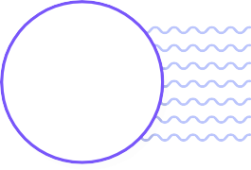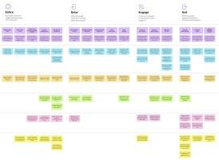

**Need some inspiration?**

See a finished version of this template to kickstart your work.

[**Open example**](https://app.mural.co/template/f59f644b-b4b4-47b5-9ed6-3a8c71ceb612/896b31fe-5597-40ef-9b06-3811a1a45ace)